**A**

**MINOR PROJECT REPORT**

**ON**

**Web Based Solution for**

**COLLEGE MANAGEMENT SYSTEM**

**Thesis submitted in partial fulfilment of the requirement for the degree**

**Of**

**MASTER IN COMPUTER APPLICATION**

# BY

**PRASHANTI PANCHANAN TURUK**

**ROLL NO: 41 MCA/2018**



# UNDER THE GUIDANCE OF

**Asst. Professor Tanuja Panda**

**Project Guide, OUAT, Bhubaneswar**

## Department of Computer Science and Application, Centre For Post Graduate Studies

**Orissa University of Agriculture and Technology Bhubaneswar-751003.**

# TABLE OF CONTENTS

**Chapter 1. Introduction**

An Overview Of The Project

Objective Of The Project

Modules Of The Project

About the Website

**Chapter 2. System Study**

Existing System

* Problems in Existing System
* Solution To The Problem Proposed System

**Chapter 3. System Analysis**

Preliminary Investigation

Feasibility Study

Request Approval

**Chapter 4. System Specification**

Hardware Specification

Software Specification

**Chapter 5. Document Designing**  Data Flow Diagram

Entity Relationship Diagram

Database Design

**Chapter 6. Coding**

**Chapter 7. Testing**

**Chapter 8. Screen Layouts**

**Chapter 9. Implementation**

**Chapter 10. Conclusion**

**Chapter 11. Bibliography**

**Chapter-1**

# INTRODUCTION

An Overview Of The Project :

“**COLLEGE MANAGEMENT SYSTEM** “is used to manage the recourses to the fullest extend & to assist the Administrator to handle the information.

This is an easy to operate user friendly, economical software that Committed to meet the all requirements to manage the users.

“**COLLEGE MANAGEMENT SYSTEM” is** one of the better software for complete management of your College/University. It can manage the user and its data excellently. The integrated features are vender data management, stock availability, sales records, purchase records, products overview, online booking of products, customer feedback and many more.

OBJECTIVE OF THE PROJECT:

The project has been carried out with the following objective in mind: Providing a web-based application, that gives information to system users.

* The system is not an internet-based application but it will be soon that can be accessed

Throughout net & can be accessed by anyone who has net connection.So

Anyone can easily book products of their choice for purchase without any problem.

* The website provides information about all the users/members of the college.
* The standards of security and data protective mechanism have been given a big choice for proper usage.
* The application takes care of different modules and their associated reports, which are produced as per the applicable strategies and standards that are put forwarded by the administrative staff.

MODULES OF THE PROJECT :-

The system comprises of 4 major modules with their sub-modules as follows:

1. **Admin**
2. **Teacher**
3. **Librarian**
4. **Student**
5. **Admin:**
   1. **Login:** Admin can login his personal account.
   2. **Add/View Student:** Admin add student detail into a system.
   3. **Add/View Teacher:** Admin add Teacher detail into a system
   4. **Add/View Librarian:** Admin add librarian detail into a system
   5. **Add Time-Table:** Admin set and add time table.
   6. **Fee Paid/Unpaid:** Admin enter fee detail into a system.
   7. **Add Event:** Admin add event detail into a system.
   8. **View/Delete Book Request:** Admin can view and delete book request from database.
   9. **View Books:** Admin can see all the books detail from database.
6. **Teacher:**
   1. **Login:** Teacher can login in his personal account.
   2. **Add Assignment:** Teacher can add assignment detail for the students.
   3. **Add Attendance:** Teacher can add attendance detail into a database.
   4. **Add Result:** Student can add result detail.
   5. **View Event:** Teacher can view event detail from database.
7. **Librarian:**
   1. **Login:** Librarian can login in his personal account.
   2. **Add Books:** Librarian can add books into database for student use.
   3. **Request a Book:** View student request for a book.
   4. **Issue a Book:** View detail of all issue books.
   5. **Return a Book:** view detail of all return book.
   6. **View Event:** Librarian can view all the events.
8. **Student:**
   1. **Login:** Student can login his personal account.
   2. **View Profile:** Student can see his profile.
   3. **View Books:** Student can view book added by librarian.
   4. **View Time-Table:** Student can view all timetable detail.
   5. **View Assignment**: Student can view all assignment detail added by teacher.
   6. **View Result:** Student can view result.
   7. **View Attendance:** Student can view attendance.
   8. **View Event:** Student can view all event detail.

## About the website :-

School/college/university Management Module which is used by Schools as well as Colleges to manage their daily activities which include the management of Employees, Students, Books and Library Records, Parents details, Assignments, Admission Process, Results and Reports, Exams, Events, Attendance, Timetable, Fees and Other Reports. It provides one-point access to manage these wide range of activities both effectively and efficiently.

* The system will be used by four people, which are Admin, Teacher, Librarian and Student.
* Admin can login using valid credentials and perform various task such as Adding a Teacher, and Librarian and also can view them.
* Admin can also add event and view books which is requested by the librarian. System allows admin to view book request received from librarian.
* Teacher can login and perform various task such as add assignment, mark attendance, upload result and view event.
* Librarian can login and perform task such as adding a single or multiple book, view added books, request a book, issue a book to students, return issued book from student and view event.
* Firstly you can get the information lists of all Members Data.

Coir India

* The site also gives information about the college profile, its achievements, the dealer list and many more.
* The site is useful to Users as they can give their feedback on the site.
* A counter in the home page denotes the number of visits to the site.

**Chapter-2**

# SYSTEM STUDY

EXISTING SYSTEM :-

Existing system refers to the system that is being followed till now. Currently, the website used by the university does not provide detailed information about the student, faculty and librarian provided by the university. This website also does not provide detailed informations about the admission procedure and academic information used by the interested applicant directly. This website does not contain any registration proress for new and old student.

**Draw backs of existing system.**

* Students cannot see their profile and detailed info.
* Students cannot view their timetables, assignments, attendance etc.
* Student, Faculty, Librarian Login are not provided
* Provide less information.
* Not Faster.
* Admin panel is not provided.
* Not Secure (Existing user can view the activity and data).

**Purpose of the System:**

The aim of proposed system is to develop a system of improved facilities where all the members of university can connect with each other. The system provides data accuracy and save disc space. The existing system has several disadvantages and many more difficulties to work well. The proposed system tries to eliminate or reduce these difficulties up to some extent. The proposed system will help the user to consume time. The system requires very low system resources.

**Advantages of Proposed System**

The system is very simple in design and to implement. The system requires very low system resources and the system will work in almost all configurations. It has got following features

▪ This system is very easy to understand and user friendly.

▪ This website helps the users to view their profile and detailed info.

▪ Teacher, Student, Librarian are connected with each other on one system.

▪ This website provides online admission procedure.

▪ This system is saving the time for student and teacher too.

▪ In this system user can connect any time whenever he/she wants.

▪ This system is secure.This System retrieves data faster.

## Chapter-3

**SYSTEM ANALYSIS**

**Analysis** is the focus of system developing and is the stage when system designers have to work at two levels of definition regarding the study of situational issues and possible solutions in terms of” what to do” and “how to do”.

System analysis is a process by which we attribute process or goals to a human activity, determine how well those purpose are being achieved and specify the requirements of the various tools and techniques that are to be used within the system if the system performances are to be achieved.

**SRS Document: -**

The document was prepared keeping the project to be developed in view. The document specifies the general procedure that has been followed by me, while the system was studied and developed. The general document was provided by the organisation as a reference guide to understand my responsibilities in developing the system, with respect to the requirements that have been pin pointed to get the exact structure of the system as stated by the actual client. The system as stated by my project guide the actual standards of the specification were desired by conducting a series of interviews and questionnaires. The collected information was organized to form the specification document and then was modelled to suite the standards of the system as intended.

**WATERFALL OR CLASSICAL LIFE CYCLE MODEL OF THE PROJECT**

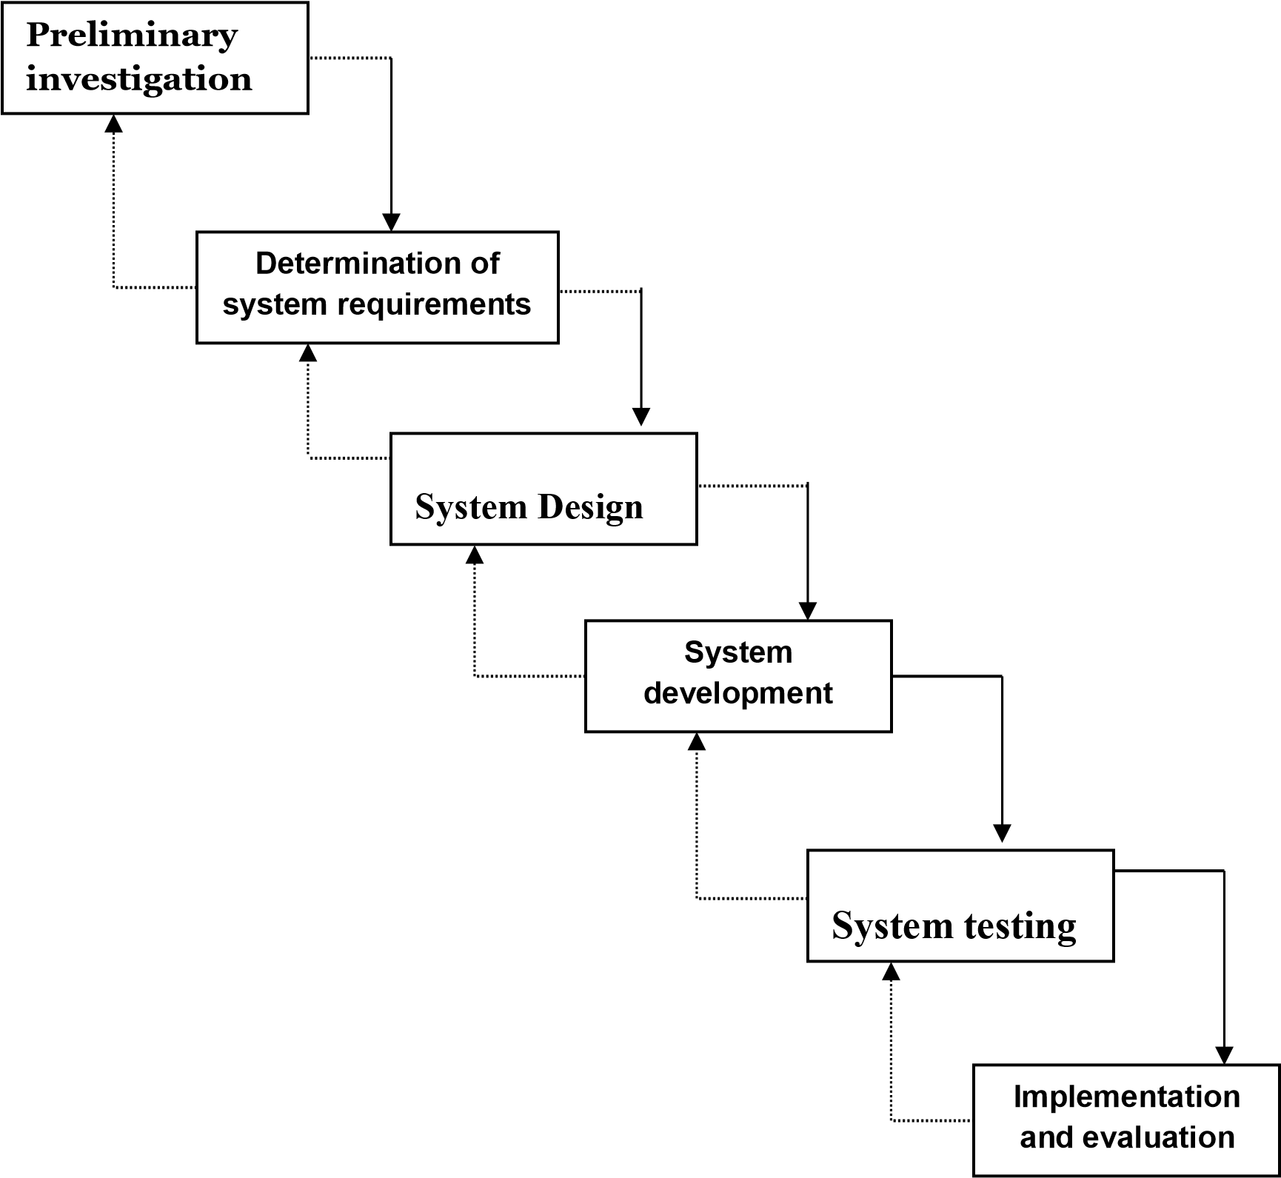

### Preliminary Investigation:-

The initial investigation has the objective of determining the validity of the user’s request for a candidate system and whether a feasibility study should be conducted.

The objectives of the problem posed by the user must be understood within the framework of the organisation’s plan. I had investigated from the concerned authority about the project.

### 1. Information Gathering:-

A key part of feasibility analysis is gathering information about the present system. The analyst must know what information to gather, where to find it, how to collect it, and what to make of it. The proper use of tools for gathering information is the key to successful analysis.

### 2. System Planning:-

Planning for information systems has a time horizon and a focus dimension. The time horizon dimension specifies the time range of the plan, whereas the focus dimensions relates whether the primary concern is strategic, managerial or operational. The systemwide. the project that I was assigned was required to complete within 20

weeks. Within that time what we planned is as follows:-

Requirement analysis, Preliminary Investigation, Information gathering to cover in 2 weeks. Since we were not aware of some tools like MySql server we had kept three weeks to understand the knot and bolts of these tools. 12 weeks for designing and coding the system under development,1week for testing and implementation and the rest two reserve weeks.

### Feasibility Report

Feasibility is an important phase in the software development process it enables the developers to have an assessment of the product being developed. It refers to the feasibility study of the product in terms of outcomes of the product, operational use and technical support required for implementing it. Feasibility study should be performed on the basis of various criteria and parameters.

**Economic Feasibility:**

It refers to the benefits or outcomes we are deriving from the product as compared to the total cost we are spending for developing the product. If the benefits are more or less the same as the older system then it is not feasible to develop the product.The product is economical feasible. The E-governance provides the following benefits to Primary School of Orissa.

* Reduces the processing time.
* Reduces the work load.
* Administration will be effective.

**Operational Feasibility**

It refers to the feasibility of the product to be operational. Some products may work very well at the design and implementation but many fail in the real time environment. The users are acquainted with windows environment, so there is necessity of trained them only to use the new system. In the existing system all the transactions are carried out manually which are time consuming. With the use of computerized system selection of the batch is easier and time saving. This is online system, which saves lots of operational time.

**Technical Feasibility**

It is seen that the system can be developed with the current equipment, with the existing software technology and with the available personnel. It can be developed with c# .net and ASP .net technology . SQL Server is used as backend. To develop the software, we need a browser like Internet Explorer. All these are available at the development center. Hence the system is technically feasible.

**Request Approval**

Hence the investigation is able to fulfill every type of requirement testes. Project has been approved finally for development by the company personnel.

## Chapter-4

**SYSTEM SPECIFICATION**

### Hardware specifications: -

* **Pentium Dual Processor.**
* **256 MB RAM.**
* **1GB Hard Disk space.**

### Software specifications :-

##### FRONT END : HTML, CSS, JAVASCRIPT

BACK END : PHP, MySQL

SERVER : APACHE SERVER

OPERATING SYSTEM : WINDOWS XP 7/8/8.1/10/11

**Chapter-5**

## DOCUMENT DESIGNING

### INTRODUCTION :-

* The entire system is projected with a physical diagram which specifics the actual storage parameters that are physically necessary for any database to be stored on to the disk. The overall systems existential idea is derived from this diagram.

* The relation upon the system is structure through a conceptual ER-Diagram, which not only specifics the existential entities but also the standard relations through which the system exists and the cardinalities that are necessary for the system state to continue.
* The content level DFD is provided to have an idea of the functional inputs and outputs that are achieved through the system. The system depicts the input and output standards at the high level of the systems existence.

### DATA FLOW DIAGRAM :-

Data Flow Diagram is a diagrammatic representation of data

movement through a system – manual or automated – from inputs to outputs through processing. The data flow diagrams help in the analysis of the flow of data through a system and thus help in identifying the system requirements.

**NOTATIONS:-**

T

his symbol represents the

Enti

ty

.



This symbol represents the Process .



This symbol represents the One way data flow.



This symbol represents the Two way data flow.



This symbol represents the Data store .

**Rules For Constructing Data Flow Diagram:-**

Squares, circles and files must bear names.

Decomposed data flow squares and circles can have same names.

Choose meaningful names for data flow.

Draw all data flows around the outside of the diagram

**SAILENT FEATURES OF DFD’s**

The DFD shows flow of data, not of control loops and decision are controlled considerations do not appear on a DFD.

The DFD does not indicate the time factor involved in any process whether the dataflows take place daily, weekly, monthly or yearly.

The sequence of events is not brought out on the DFD

#### Context Free Diagram:-

A DFD may consist of a number of levels. The top-level diagram is called a **Context Free Diagram**, which consists of one single process.

**(dfd)**

### ENTITY RELATIONSHIP DIAGRAM :-

The Entity Relationship(ER) data model is based on a perception of a real world that consists of a real world that consists of a set of objects called ENTITY/ENTITIES., and of relationships among these objects. There are the three basic notations that ER data model employs: Entity Set, Relationship Set and Attributes.

This

symbol represents the Enti

ty

.



This symbol represents the Relationship set.



This symbol represents the Attributes.

(e-r)

#### DATABASE DESIGN :-

The integrated collection of data is usually referred to as database. The records for different entities are stored in database. The database contains information about particular system/ about the enterprise. The data storage, retrieval and maintenance are carried out by the database management.

The details of each table including the structure, data type and different constraints (i.e. Primary key and foreign key) are as follows:

**(table description)**

**Data Dictionary**

**Table Name: - Student_Registration**

|  |  |  |  |
| --- | --- | --- | --- |
| **Field Name** | **Data Type** | **Field Size** | **Field Description** |
| Id | Id | 20 | Primary |
| DP | LONGBLOB | - | - |
| First_Name | Varchar | 20 | - |
| Last_Name | Varchar | 7 | - |
| Department | Varchar | 10 | - |
| Year | Varchar | 10 | - |
| Btach | Varchar | 30 | - |
| Contact_No | Int | 10 | - |
| Email | Varchar | 30 | - |
| Password | Varchar | 20 | - |
| Total_Fee | Varchar | 15 | - |
| Paid_Fee | Varchar | 30 | - |
| Gender | Varchar | 10 | - |

**Table Name: - Faculty_Registration**

|  |  |  |  |
| --- | --- | --- | --- |
| **Field Name** | **Data Type** | **Field Size** | **Field Description** |
| Id | Int | 20 | Primary |
| DP | LONGBLOB | - | - |
| First_Name | Varchar | 20 | - |
| Last_Name | Varchar | 7 | - |
| Gender | Varchar | 10 | - |
| Department | Varchar | 10 | - |
| Designation | Varchar | 30 | - |
| Qualification | Int | 10 | - |
| Contact | Varchar | 30 | - |
| Email | Varchar | 20 | - |
| Password | Varchar | 15 | - |

**Table Name: - Librarian_Registration**

|  |  |  |  |
| --- | --- | --- | --- |
| **Field Name** | **Data Type** | **Field Size** | **Field Description** |
| Id | Int | 20 | Primary |
| DP | LONGBLOB | - | - |
| First_Name | Varchar | 20 | - |
| Last_Name | Varchar | 7 | - |
| Gender | Varchar | 10 | - |
| Contact | Varchar | 10 | - |
| Email | Varchar | 30 | - |
| Password | Int | 10 | - |

**Table Name: - Admin_Registration**

|  |  |  |  |
| --- | --- | --- | --- |
| **Field Name** | **Data Type** | **Field Size** | **Field Description** |
| Id | Int | 20 | Primary |
| First_Name | Varchar | 20 | - |
| Last_Name | Varchar | 7 | - |
| Gender | Varchar | 10 | - |
| Contact | Varchar | 10 | - |
| Email | Varchar | 30 | - |
| Password | Int | 10 | - |

**Table Name: - Issue_Book**

|  |  |  |  |
| --- | --- | --- | --- |
| **Field Name** | **Data Type** | **Field Size** | **Field Description** |
| Id | Int | 20 | Primary |
| Departmnt | Varchar | 20 | - |
| Enrollment_No | Varchar | 7 | - |
| Book_Name | Varchar | 10 | - |
| Author_Name | Varchar | 10 | - |
| Price | Varchar | 30 | - |
| Student_Name | Int | 10 | - |

**Table Name: - Add_Book**

|  |  |  |  |
| --- | --- | --- | --- |
| **Field Name** | **Data Type** | **Field Size** | **Field Description** |
| Id | Int | 20 | Primary |
| Departmnt | Varchar | 20 | - |
| Book_Name | Varchar | 7 | - |
| Author_Name | Varchar | 10 | - |
| Price | Int | 8 | - |

**Table Name: - Request_Book**

|  |  |  |  |
| --- | --- | --- | --- |
| **Field Name** | **Data Type** | **Field Size** | **Field Description** |
| Id | Int | 20 | Primary |
| Departmnt | Varchar | 20 | - |
| Book_Name | Varchar | 7 | - |
| Author_Name | Varchar | 10 | - |
| Price | Int | 10 | - |
| Quantity | Int |  |  |

**4.5 .8 Table Name: - Time_Table**

|  |  |  |  |
| --- | --- | --- | --- |
| **Field Name** | **Data Type** | **Field Size** | **Field Description** |
| Id | Int | 20 | Primary |
| File | LONGBLOB | - | - |
| Departmnt | Varchar | 20 | - |
| Year | Varchar | 7 | - |
| Name | Varchar | 10 | - |

**4.5 .9 Table Name: - Assignment**

|  |  |  |  |
| --- | --- | --- | --- |
| **Field Name** | **Data Type** | **Field Size** | **Field Description** |
| Id | Int | 20 | Primary |
| File | LONGBLOB | - | - |
| Departmnt | Varchar | 20 | - |
| Year | Varchar | 7 | - |
| Name | Varchar | 10 | - |

**4.6.0 Table Name: - Result**

|  |  |  |  |
| --- | --- | --- | --- |
| **Field Name** | **Data Type** | **Field Size** | **Field Description** |
| Id | Int | 20 | Primary |
| File | LONGBLOB | - | - |
| Departmnt | Varchar | 20 | - |
| Year | Varchar | 7 | - |
| Name | Varchar | 10 | - |

**4.6.1 Table Name: - Attendence**

|  |  |  |  |
| --- | --- | --- | --- |
| **Field Name** | **Data Type** | **Field Size** | **Field Description** |
| Id | Int | 20 | Primary |
| File | LONGBLOB | - | - |
| Departmnt | Varchar | 20 | - |
| Year | Varchar | 7 | - |
| Name | Varchar | 10 | - |

**4.6.2 Table Name: - Add_Event**

|  |  |  |  |
| --- | --- | --- | --- |
| **Field Name** | **Data Type** | **Field Size** | **Field Description** |
| Id | Int | 20 | Primary |
| File | LONGBLOB | - | - |
| Event_Name | Varchar | 20 | - |
| Event_Date | Varchar | 7 | - |

**Chapter-6**

# CODING

**PHP**

PHP is a server side scripting language. that is used to develop Static websites or Dynamic websites or Web applications. PHP stands for Hypertext Pre-processor, that earlier stood for Personal Home Pages. It is widely-used open source general-purpose scripting language that is especially suited for web development and can be embedded into HTML.

PHP code may be embedded into HTML code, or it can be used in combination with various [web template systems](https://en.wikipedia.org/wiki/Web_template_system), web content management systems, and [web frameworks](https://en.wikipedia.org/wiki/Web_framework). PHP code is usually processed by a PHP [interpreter](https://en.wikipedia.org/wiki/Interpreter_(computing)) implemented as a [module](https://en.wikipedia.org/wiki/Plugin_(computing)) in the web server or as a [Common Gateway Interface](https://en.wikipedia.org/wiki/Common_Gateway_Interface) (CGI) executable.

**Basics of PHP:**

1. **Basic PHP Syntax**

* A PHP script can be placed anywhere in the document.
* A PHP script starts with **<?php** and ends with **?>**:

Eg**:**

<?php  
echo "HelloWorld!";  
?>

1. **Creating (Declaring) PHP Variables**

In PHP, a variable starts with the $ sign, followed by the name of the variable:

Eg:

<?php  
$txt = "Hello world!";  
$x = 5;  
$y = 10.5;  
?>

1. **PHP - A Simple HTML Form**

The example below displays a simple HTML form with two input fields and a submit button:

Eg:

<html>  
<body>  
  
<form action="welcome.php" method="post">  
Name: <input type="text" name="name"><br>  
E-mail: <input type="text" name="email"><br>  
<input type="submit">  
</form>  
</body>  
</html>

1. **PHP Form Validation Example**

**Valid URL**

Below code shows validation of URL

$website = input($_POST["site"]);

if (!preg_match("/\b(?:(?:https?|ftp):\/\/|www\.)[-a-z0-9+&@#\/%?=~_|!:,.;]*[-a-z0-9+&@#\/%=~_|]/i",$website)) {

$websiteErr = "Invalid URL";

}

**Valid Email**

Below code shows validation of Email address

$email = input($_POST["email"]);

if (!filter_var($email, FILTER_VALIDATE_EMAIL)) {

$emailErr = "Invalid format and please re-enter valid email";

}

**Selection list Validation**

if (isset($_POST['submit'])) {

if(empty($_POST['package']))

$msg_package = "You must select a package";

}

**Validation for non-empty, alphabets and whitespace only**

if (isset($_POST['submit'])) {

//checking name

if(empty($_POST['full_name']))

$msg_name = "You must supply your name";

$name_subject = $_POST['full_name'];

$name_pattern = '/^[a-zA-Z ]*$/';

preg_match($name_pattern, $name_subject, $name_matches);

if(!$name_matches[0])

$msg2_name = "Only alphabets and white space allowed";

}

1. **PHP Database Connectivity**

<?php  
$servername = "localhost";  
$username = "username";  
$password = "password";  
  
// Create connection  
$conn = new mysqli($servername, $username, $password);  
  
// Check connection  
if ($conn->connect_error) {  
    die("Connection failed: " . $conn->connect_error);  
}   
echo "Connected successfully";  
?>

**HTML**

**Hypertext Markup Language** (**HTML**) is the standard markup language for creating web pages and web applications. With Cascading Style Sheets (CSS) and JavaScript it forms a triad of cornerstone technologies for the World Wide Web.Web browsers receive HTML documents from a web server or from local storage and render them into multimedia web pages. HTML describes the structure of a web page semantically and originally included cues for the appearance of the document.

Basic HTML Tag:

1. **Image tag**

* You can insert any image in your web page by using **<img>** tag.
* A simple syntax to use HTML <img> tag is as follows-

<img src = "Image URL" ... attributes-list/>

* The <img> tag is an empty tag, which means that, it can contain only list of attributes and it has no closing tag.

1. **Div tag**

* The <div> tag defines a division or a section in an HTML document.
* The <div> tag is used to group block-elements to format them with CSS.

1. **Marquee tag**

* An HTML marquee is a scrolling piece of text displayed either horizontally across or vertically down your webpage depending on the settings.
* A simple syntax to use HTML <marquee> tag is as follows –

<marquee attribute_name = "attribute_value"....more attributes>

One or more lines or text message or image

</marquee>

1. **Div tag**

* The <div> tag defines a division or a section in an HTML document.
* The <div> tag is used to group block-elements to format them with CSS.
* A simple syntax to use HTML <img> tag is as follows-

<div>

Div element

</div>

1. **Anchor**

* The **HTML anchor tag** defines a hyperlink that links one page to another page. The "href" attribute is the most important attribute of the HTML a tag.
* The href attribute is used to define the address of the file to be linked. In other words, it points out the destination page.
* The syntax of HTML anchor tag is given below.

<a href = “…………….”> Link Text </a>

**Cascading Style Sheets (CSS)**

**Cascading Style Sheets** (**CSS**) is a style sheet language used for describing the presentation of a document written in a markup language. Although most often used to set the visual style of web pages and user interfaces written in HTML and XHTML, the language can be applied to any XML document, including plain XML, SVG and XUL, and is applicable to rendering in speech, or on other media. Along with HTML and JavaScript, CSS is a cornerstone technology used by most websites to create visually engaging webpages, user interfaces for web applications, and user interfaces for many mobile applications.

**Basic CSS Syantax:**

1. ***The element Selector***

* The element selector selects elements based on the element name.
* You can select all <p> elements on a page like this (in this case, all <p> elements will be left-aligned, with a blue text color.
* Example

**p {  
  text-align: left;  
  color: blue;  
}**

1. ***CSS Margins***

* The CSS margin properties are used to create space around elements, outside of any defined borders.
* With CSS, you have full control over the margins. There are properties for setting the margin for each side of an element (top, right, bottom, and left).
* Example

p {  
   margin-top: 100px;  
   margin-bottom: 100px;  
   margin-right: 150px;  
   margin-left: 80px;  
}

1. ***CSS Padding***

* The CSS padding properties are used to generate space around an element's content, inside of any defined borders.
* With CSS, you have full control over the padding. There are properties for setting the padding for each side of an element (top, right, bottom, and left).
* Example

div {  
   padding-top: 50px;  
   padding-right: 30px;  
   padding-bottom: 50px;  
   padding-left: 80px;  
}

**JAVASCRIPT**

**JavaScript**, often abbreviated as **JS**, is a high-level, dynamic, weakly typed, prototype-based, multi-paradigm, and interpreted programming language. Alongside HTML and CSS, JavaScript is one of the three core technologies of World Wide Web content production. It is used to make webpages interactive and provide online programs, including video games. The majority of websites employ it, and all modern web browsers support it without the need for plug-ins by means of a built-in JavaScript engine.

**Basics of JavaScript:**

1. **The <script> Tag**

* In HTML, JavaScript code must be inserted between <script> **Eg**:

<script>  
document. getElementById("demo"). innerHTML = "My First JavaScript";  
</script>

1. **JavaScript in <head> or <body>**

* You can place any number of scripts in an HTML document.
* Scripts can be placed in the <body>, or in the <head> section of an HTML page, or in both.

1. **JavaScript Display Possibilities**

JavaScript can "display" data in different ways:

* Writing into an HTML element, using **innerHTML**.
* Writing into the HTML output using **document.write()**.
* Writing into an alert box, using **window.alert()**.
* Writing into the browser console, using **console.log()**.

1. **JavaScript Functions**

* A JavaScript function is a block of code designed to perform a particular task.
* A JavaScript function is executed when "something" invokes it (calls it).

Eg 1:

function myFunction(p1, p2) {  
    return p1 * p2;   // The function returns the product of p1 and p2  
}

Eg 2:

var x = myFunction(4, 3);    // Function is called, return value will end up in x  
  
function myFunction(a, b) {  
    return a * b;            // Function returns the product of a and b  
}

1. **JavaScript Validation**

**Regular Expressions**

The following is how regular expressions can be used

* **[abc]** – find any character in the brackets a, b or c
* **[a-z]** – find the range of characters within brackets i.e. a to z lowercase. Can also be used with numbers [0-9]
* **[^xyz]** – find any character other than the ones specified in the brackets i.e. x,y and z
* **(word)** – find the “word” specified in the round brackets
* **[abc|xyz]** – find either the characters a,b,c or x,y,z

1. **Javascript Validation Numeric**

We’ll start first with validating a textbox that accepts only numbers. So the condition is we check whether the textbox contains anything ELSE other than numbers and display a message

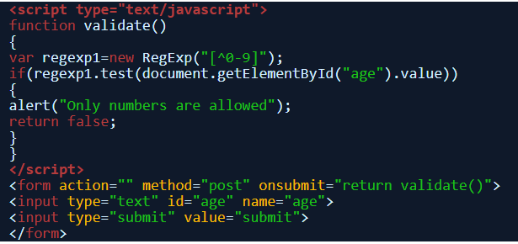

1. **Javascript Validation Alphabets**

From numbers we’ll move to alphabets first an example for validation lowercase alphabets and then to validate both uppercase and lowercase.

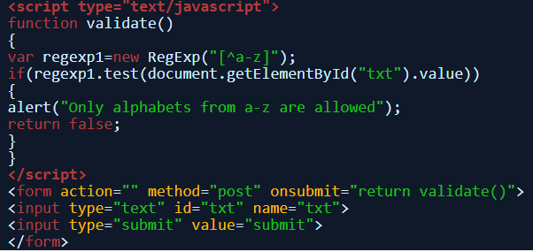

1. **Javascript validation check for a word**

This type of javascript validation will check if the entered text contains a particular word round brackets are used to find out complete words

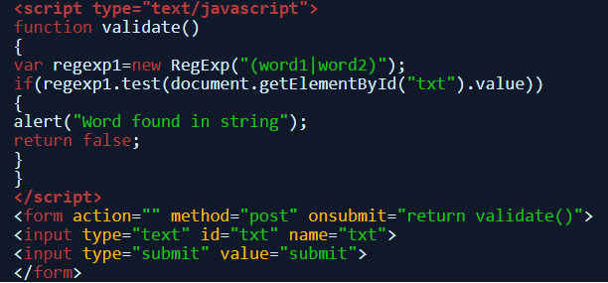

1. **Javascript Validation whitespace**

Validate a string against any whitespaces including tab and carriage return using the pattern and match function

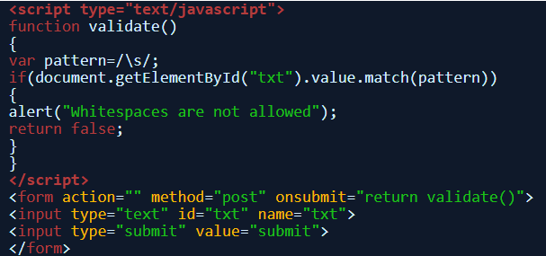

**MySQL**

Microsoft SQL server is a relational database management system (RDBMS). As a database server, it is a software product with the primary function of storing and retrieving data as requested by other software applications—which may run either on the same computer or on another computer across a network (including the Internet).

MySQL is the world's most popular open source database. With its proven performance, reliability and ease-of-use, MySQL has become the leading database choice for web-based applications, used by high profile web properties including Facebook, Twitter, YouTue, Yahoo and many more.

**Highlighted Query**

1. ***SQL Create Table Statement***

* The CREATE TABLE statement is used to create a new table in a database.
* **Syntax**

**CREATE TABLE *table_name*(  
*column1 datatype*,  
*column2 datatype*,  
*column3 datatype*,  
   ....  
);**

1. **SQL insert Statement**

* The INSERT INTO statement is used to insert new records in a table.
* **Insert Syntax**

**INSERT INTO *table_name* (*column1*,*column2*,*column3*, ...)  
VALUES (*value1*,*value2*,*value3*, ...);**

**Apache Web Server**

Apache Web Server is an open-source web server creation, deployment and management software. Initially developed by a group of software programmers, it is now maintained by the Apache Software Foundation. Apache Web Server is designed to create web servers that have the ability to host one or more HTTP-based websites. Notable features include the ability to support multiple programming languages, server-side scripting, an authentication mechanism and database support. Apache Web Server can be enhanced by manipulating the code base or adding multiple extensions/add-ons.

It is also widely used by web hosting companies for the purpose of providing shared/virtual hosting, as by default, Apache Web Server supports and distinguishes between different hosts that reside on the same machine.

**Chapter-7**

## TESTING

Testing

**SYSTEM TESTING:**

System testing is an expensive but critical process that takes as much as 50% of the budget for program development. It can be defined as the process of executing a program with the explicit intention of finding errors i.e. making the program fail. A successful test is one that finds error. In the context of our system following testing strategies are use to find out errors.

**Testing Strategies**

***Code Testing:***

The code testing examines the logic of the program, by testing every path of the program. A path is a specific combination of conditions that is handled by the program in this system each path of the program is tested using a number of message boxes and a number of appropriate test data for each path.

***Unit Testing:***

Individual components are tested to ensure that they operate correctly. A bottom- up unit strategy is followed for this system. Well-designed driver programs are used in this approach.

***Integration Testing:***

Integration Testing is a systematic technique for constructing the program structure while at the same time conducting tests to uncover errors associated with interfacing. The objective is to take unit tested components and build a program structure that has been dictated by design. Taking the big bang approach to integration is a lazy strategy that is doomed to failure. Integration testing should be conducted incrementally.

***System Testing:***

System testing is actually a series of different tests whose primary purpose is to fully exercise the computer-based system. There is some System test, which are worthwhile for software-based system. Under System testing Recovery Testing, Security Testing, Stress Testing and Performance Testing are conducted to validate software once it has been incorporated into a larger system.

***Testing with Dummy Data:***

This test was done with wrong data, validating them and making the system fail forcefully, and the system finally is found bug free.

**Chapter-8**

## SCREEN LAYOUTS



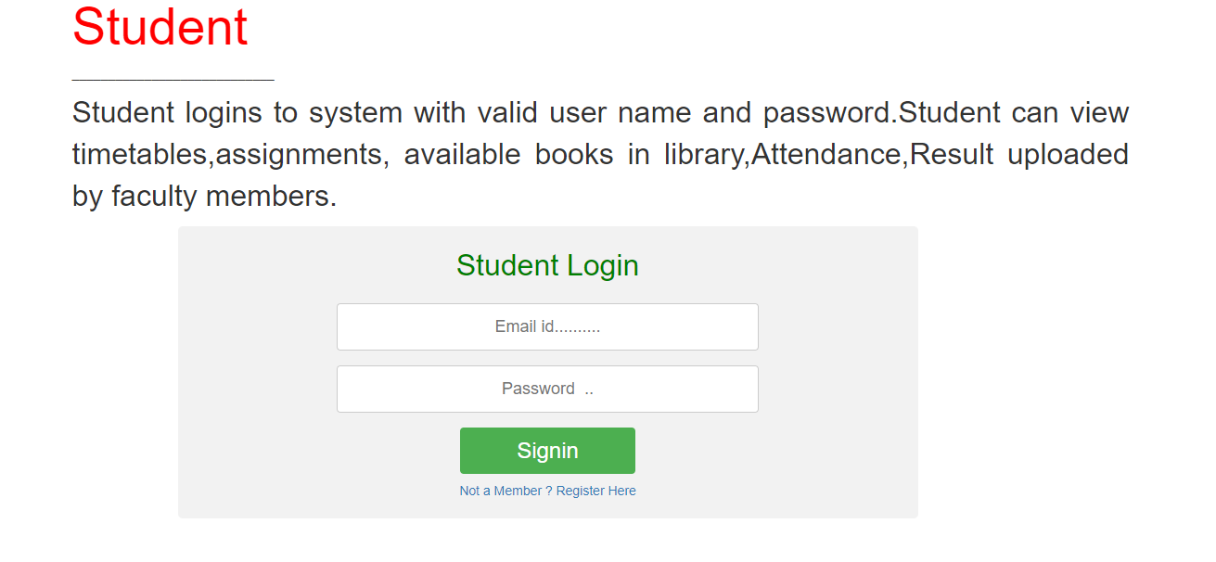



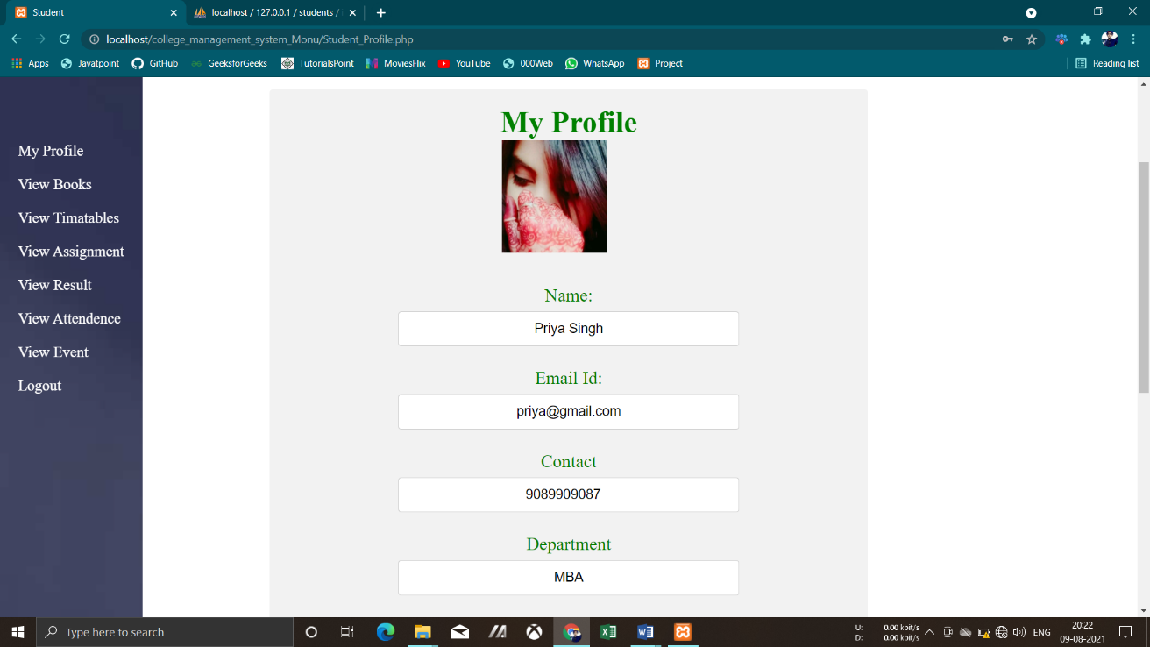

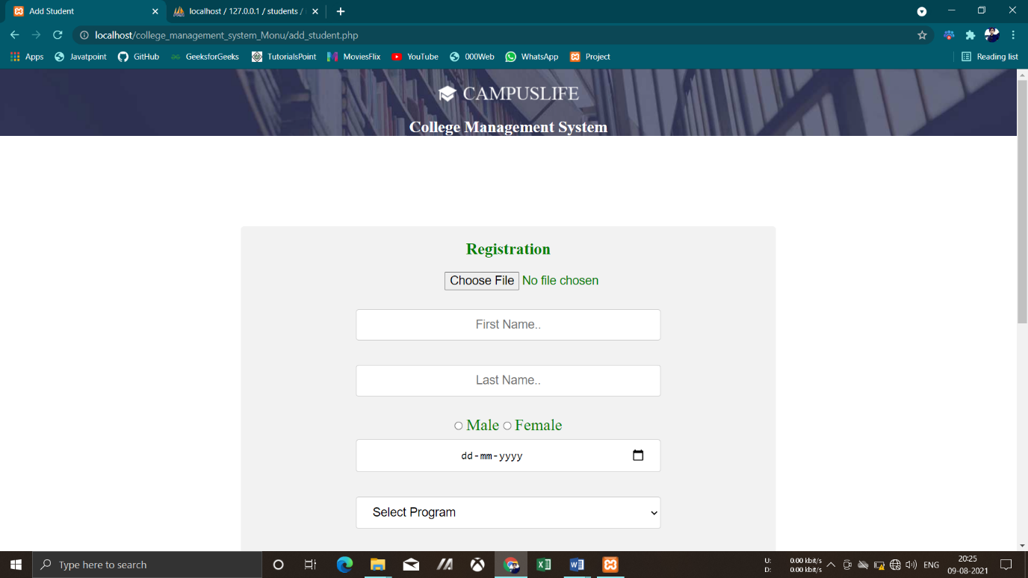

**Chapter-9**

## IMPLEMENTATION

SYSTEM IMPLEMENTATION:

Implementation is the stage of the project when the theoretical design turned into a working system. At this stage the main workload, the up heal and the major impact on the existing practices shift to user department. If the implementation stage is not carefully planned and controlled, it can cause chaos. Thus it can be considered to be the most crucial stage in achieving a new successful system and in giving the users confidence that the users confidence that the new system will work and be effective.

Implementation involves careful planning, investigation of current system and constraints on implementation, design of methods to achieve the changeover, training of staff in the changeover procedures and evaluation of changeover methods. The first task is the implementation planning i.e. deciding the methods and time scale to be adopted.

Requirements keep changing with time so the implementation of this project may change with time hence implementation is an ongoing process, which may change in future.

Maintenance

The site is online, it will inevitably need to be updated to keep your content fresh. Sometimes it’s a simple change, like changing a date or adding an event or you may want to add a new section or functionality to your site involving page-wise modification

**Chapter-10**

## CONCLUSION

### CONCLUSION

The entire project **“COLLEGE MANAGEMENT SYSTEM”** has been developed and deployed as per the requirements specification. It is found to be bug free as per the testing standards that are implemented. There is always some scope of improvement in any software package however efficient it may be. This website has been developed in such a way that new features can be incorporated and existing features can be modified without bringing in any major changes in the design and objective of the website.

It has been observed that the report generation is easier and now compared with the manual operation. These are found to be more accurate because of availability of information from various levels. The approach in developing the website has been to make Software as flexible, functional and user friendly as possible.

**­**

**Chapter-11**

**BIBLIOGRAPHY**

BIBLIOGRAPHY:-

**BOOK**

* Web Technology Black Book

Web References :-

* Nevon Projects
* W3School
* JavaTpoin
* PhpTpoint
* TutorialPoint
* Wikipedia
* Web Technology Black Book
* PHP The Complte Reference
* Kudvenkat
* Tutorial Point
* Stack Overflow
* OUAT

#### SYNOPSIS

School/college/university Management Module which is used by Schools as well as Colleges to manage their daily activities which include the management of Employees, Students, Books and Library Records, Parents details, Assignments, Admission Process, Results and Reports, Exams, Events, Attendance, Timetable, Fees and Other Reports. It provides one-point access to manage these wide range of activities both effectively and efficiently.

* The system will be used by four people, which are Admin, Teacher, Librarian and Student.
* Admin can login using valid credentials and perform various task such as Adding a Teacher, Student and Librarian and also can view them.
* Admin can also add Time Table and Event details. System allows admin to view book request received from librarian.
* Teacher can login and perform various task such as add assignment, mark attendance, upload result and view event.
* Librarian can login and perform task such as adding a single or multiple books, view added books, request a book, issue a book to students, return issued book from student and view event.
* Student can access the system by providing valid credentials access modules such as viewing their own profile, view books, view time-table, assignments, result, attendance and event.
* Super admin is the root node who adds the colleges into the system with their details. Also can view/delete a college from the system.
* Proposed system is easy to understand and user friendly too.
* In that system admin who handle the data.
* Admin can take information regarding fee detail.

Managing a school, university, college or any educational institution without a perfect software solution in the present times is painful, same in the case of any enterprises or business. Hence an appropriate solution is required which can ensure the smooth functioning of the organization as a whole, and with ERP college Management Module, this problem can simply be solved.